Problem Statement

Credit Card Lead Prediction
Happy Customer Bank is a mid-sized private bank that deals in all inds of banking products, like Savings accounts, Current accounts, investment products, credit products, among other offerings. The bank also cross-sells products to its existing customers and to do so they use different kinds of communication like tele-calling, e-mails, recommendations on net banking, mobile banking, etc. In this case, the Happy Customer Bank wants to cross sell its credit cards to its existing customers. The bank has identified a set of customers that are eligible for taking these credit cards.
Now, the bank is looking for your help in identifying customers that could show higher intent towards a recommended credit card, given:
- Customer details (gender, age, region etc.)
- Details of his/her relationship with the bank (Channel_Code,Vintage, 'Avg_Asset_Value etc.)

Data Dictionary:-

Train Data
Variable | Definition
ID | Unique Identifier for a row
Gender | Gender of the Customer
Age | Age of the Customer (in Years)
Region_Code | Code of the Region for the customers
Occupation | Occupation Type for the customer
Channel_Code | Acquisition Channel Code for the Customer (Encoded)
Vintage | Vintage for the Customer (In Months)
Credit_Product | If the Customer has any active credit product (Home loan, Personal loan, Credit Card etc.)
Avg_Account_Balance | Average Account Balance for the Customer in last 12 Months
Is_Active | If the Customer is Active in last 3 Months
Is_Lead(Target) | If the Customer is interested for the Credit Card (0 : Customer is not interested,1 : Customer is interested)
Test Data
Variable | Definition
ID | Unique Identifier for a row
Gender | Gender of the Customer
Age | Age of the Customer (in Years)
Region_Code | Code of the Region for the customers
Occupation | Occupation Type for the customer
Channel_Code | Acquisition Channel Code for the Customer (Encoded)
Vintage | Vintage for the Customer (In Months)
Credit_Product | If the Customer has any active credit product (Home loan, Personal loan, Credit Card etc.)
Avg_Account_Balance | Average Account Balance for the Customer in last 12 Months
Is_Active | If the Customer is Active in last 3 Months

Sample Submission:-
This file contains the exact submission format for the predictions. Please submit CSV file only.
Variable | Definition
ID | Unique Identifier for a row
Is_Lead | (Target) Probability of Customer showing interest (class 1)

- Add the required packages for
  - Aesthetics
  - General
  - Visualisation
  - Machine Learning
  - Utils
  - Feature Selection
  - Models
  - Unsupervised Models
  - Metrics
  - Fixing Seed

EDA(Exploratory data analysis)
We will have a basic look around the data we have at hand first to see what columns we have in the training data.From the column keys in problem statement we know the information about each of the features

1 : Customer is interested
We can get a naive idea about the type of variables form the definition itself and looking at the data makes it clearer.
Column name Null Values
ID 0
Gender 0
Age 0
Region_Code 0
Occupation 0
Channel_Code 0
Vintage 0
Credit_Product 29325
Avg_Account_Balance 0
Is_Active 0
Is_Lead 0
We can see that there are some Null values in some columns. Which is not good for data ingestion into any model, so let's see the Null situation upfront

Null Values
Train
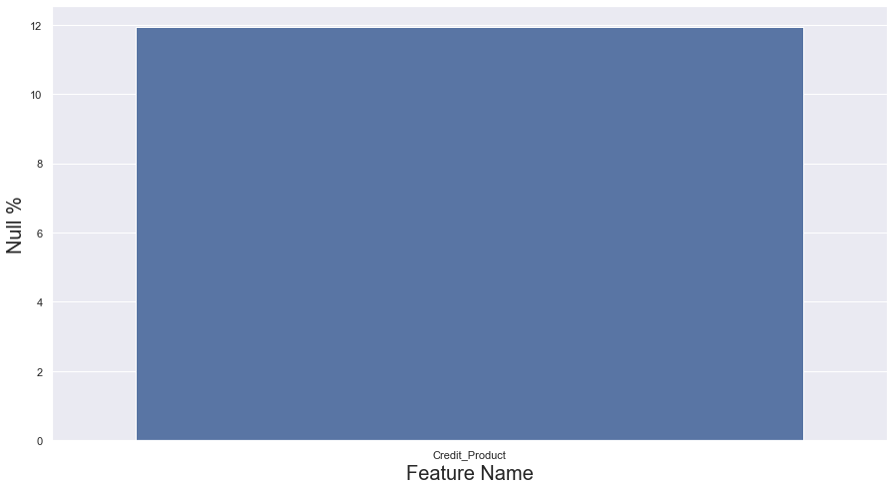

Test
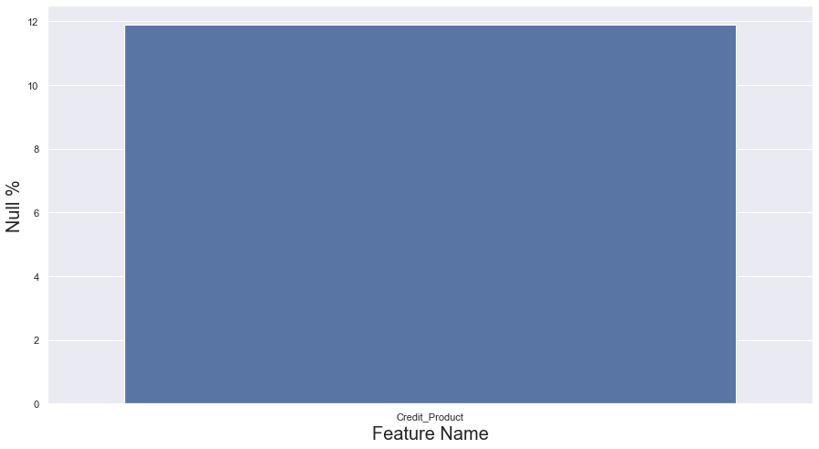
The situation is almost similar in both train set and test set; Around 12% of the values from 'Credit_Product' column is missing. And looking at the feature definition of the missing column we can assume that the NaN values in credit product means we do not know is the user has/does not have any active credit product. So, we can replace Nan with 'Unknown' and create another binary column to track the same:-
We created a new column ‘Credit_Product_Known’ to check whether the data is missing or not. In this case the value is simple 0 and 1. Value is 0 if the value in the credit_product column is 'Unk' otherwise it is 1.
Column Name Null Values
ID 0
Gender 0
Age 0
Region_Code 0
Occupation 0
Channel_Code 0
Vintage 0
Credit_Product 0
Avg_Account_Balance 0
Is_Active 0
Is_Lead 0
Credit_Product_Known 0
dtype: int64
Now that we have resolved all the null values, let's move on to EDA starting with class imbalance of the Dataset.

2. Class Imbalance
As this is a classification problem, let's start from the population of each class in out training set.
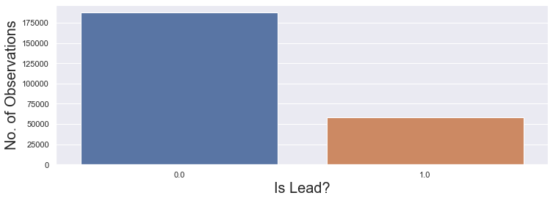
Imbalance ratio: 3.215704776283283
Okay, so it is an imbalanced set. We must keep that in mind while modelling and choosing hyper-parameters later.

3. Feature Value Counts
Let's see how many unique values there in each feature are.
Column Name Unique Values
ID 245725
Gender 2
Age 63
Region_Code 35
Occupation 4
Channel_Code 4
Vintage 66
Credit_Product 3
Avg_Account_Balance 135292
Is_Active 2
Is_Lead 2
Credit_Product_Known 2
dtype: int64
There are a mix of certain continuous, high cardinality categorical and low cardinality categorical features.
Now let's look at each individual feature separately and understand the data.

4. Gender
This feature contains the Gender data of the customer
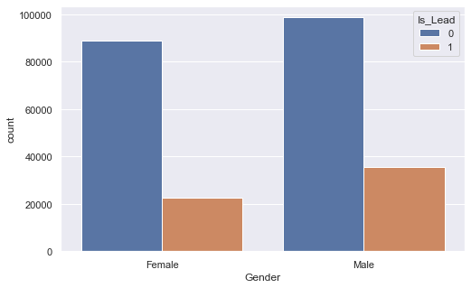
Response Rate from Gender:
we create a new variable here names v which calculates the response ratio of each gender using group by function. we check for value 1 in the 0 and 1 of both genders
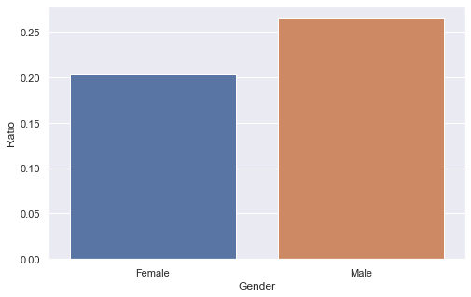
- There are more number of observations from Male customers as compared to Female customers in the training data.
- According to the dataset, Male gender has better conversion ratio than Female gender.

5. Age
Age of the Customer (in Years)
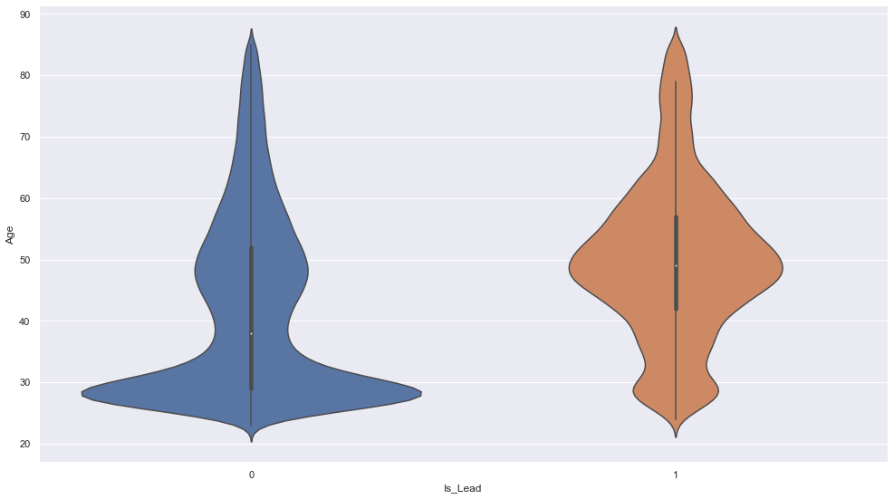
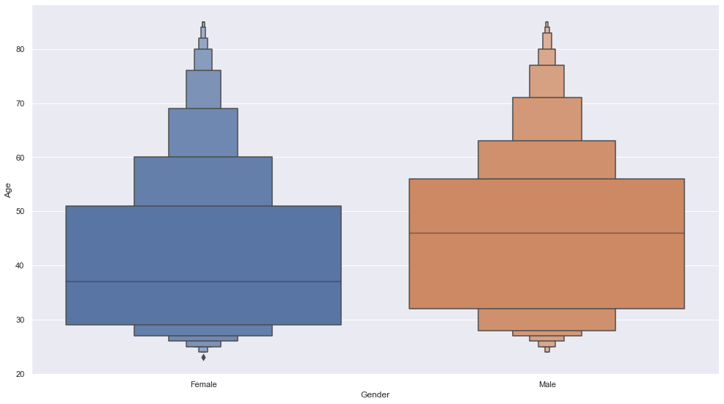
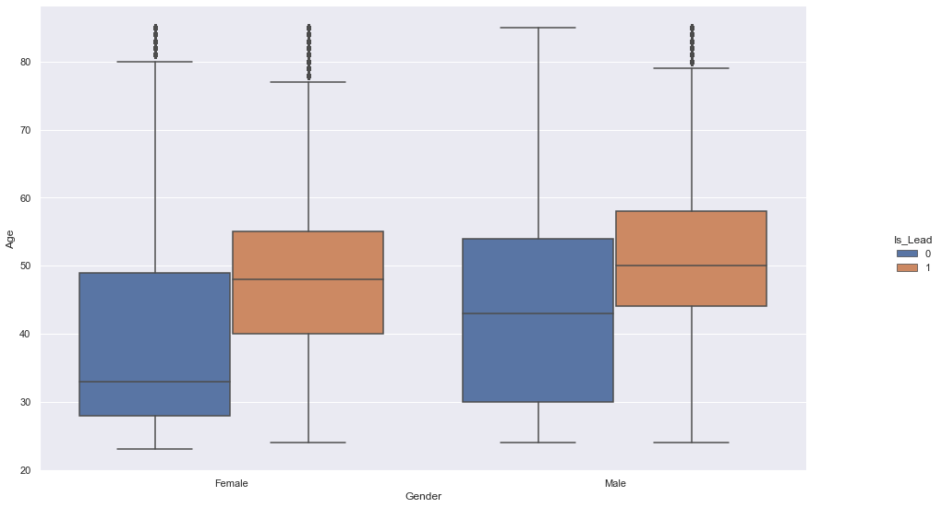
- On an average, more aged people are likely to respond positively to our offer.
- The average age of male in dataset is > average age of female.
- If we split by gender, the average age of positively responding male is > average of positively responding Female.

6. Region Code
Code of the Region for the customers
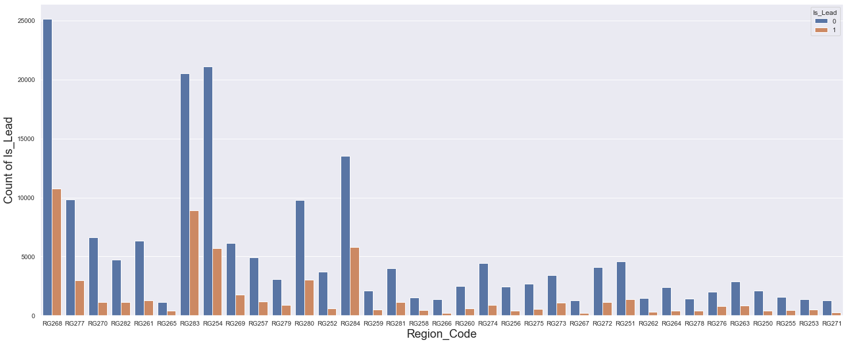
Response Rate from Cities
we create a new variable here names v which calculates the response ratio all regions using group by function. we check for value 1 in the 0 and 1 for all the regions
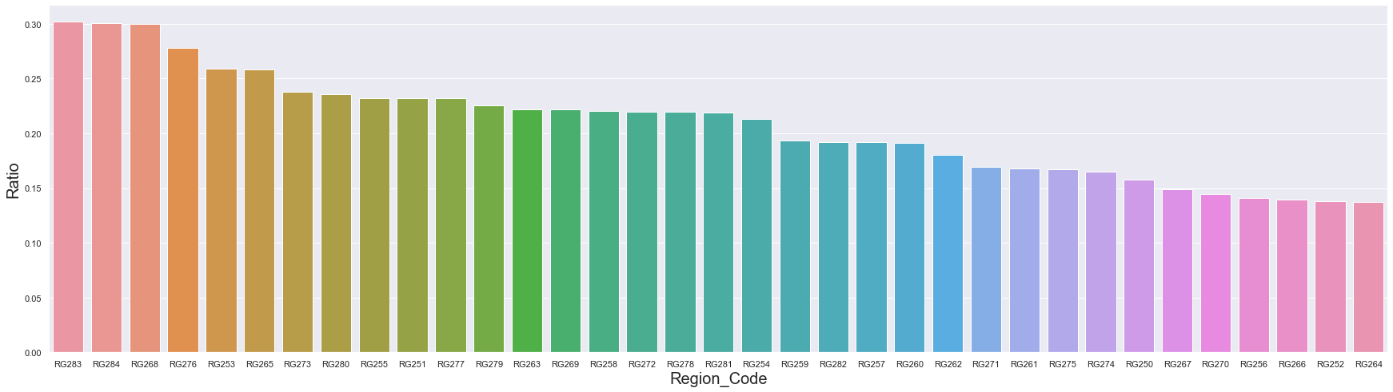

7. Occupation
Occupation Type for the customer
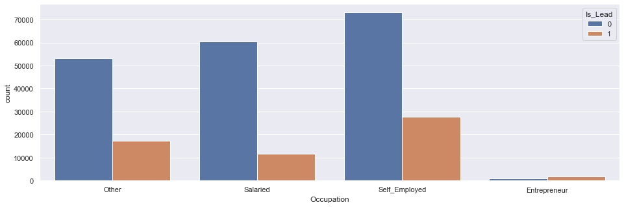
Response Rate from Occupation
we create a new variable here names v which calculates the response ratio all occupations using group by function. we check for value 1 in the 0 and 1 for all the occupations
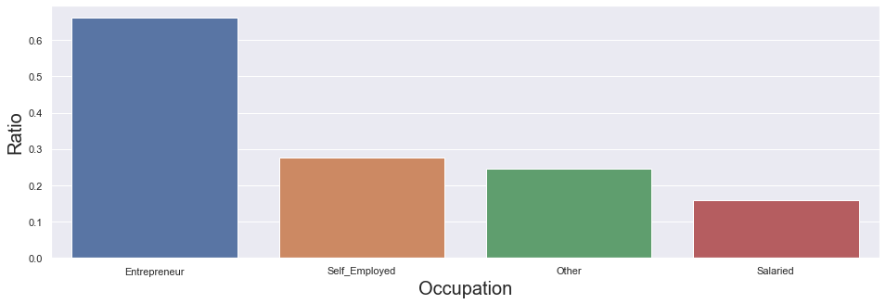
- The customer base in training data are majorly Self-Employed or Salaried.
- Entrepreneurial customers are way more likely to respond positively to our Credit Card offer.
- Salaried people are least likely to respond positively to our offer.

8. Channel Code
Acquisition Channel Code for the Customer (Encoded)
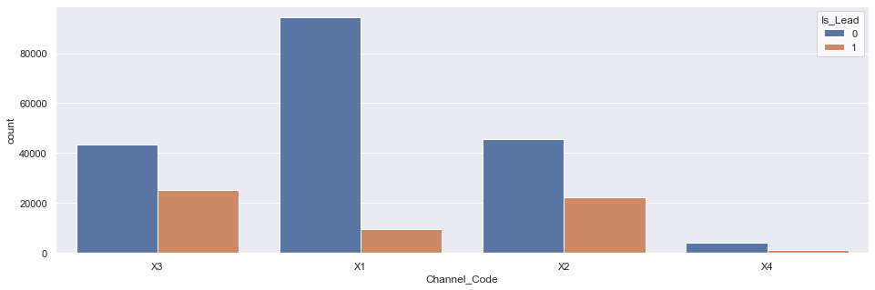
Response Rate from Channel_Code
we create a new variable here names v which calculates the response ratio all Channel_code using group by function. we check for value 1 in the 0 and 1 for all the Channel_code
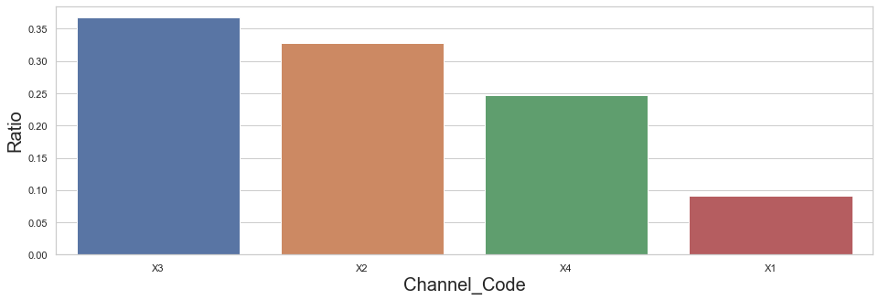
- Customer acquired through X3 channel are most likely to respond positively and X1 are least likely.

9. Vintage
Vintage for the Customer (In Months)
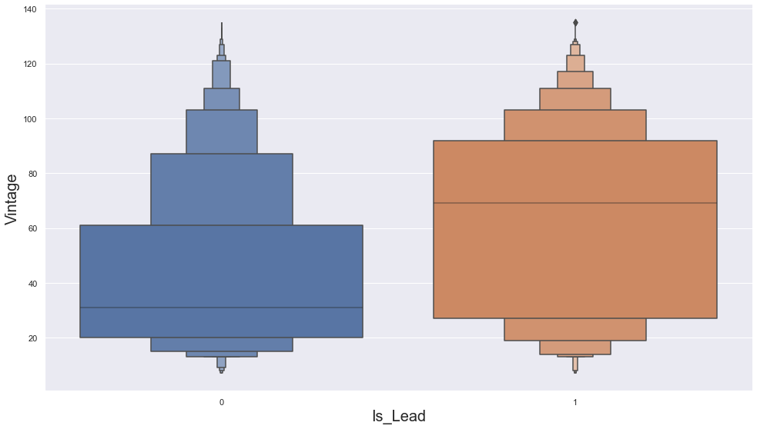
- Customers having a higher Vintage on an average are more likely to respond positively.

10. Credit Product
If the Customer has any active credit product (Home loan, Personal loan, Credit Card etc.)
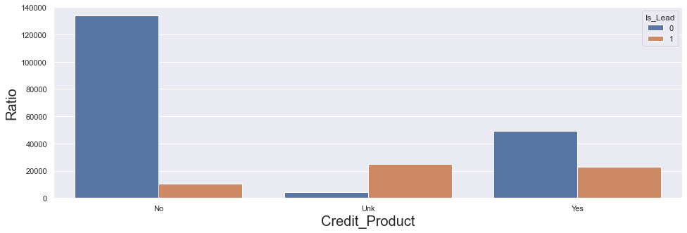
Response Rate from Credit_Product
we create a new variable here names v which calculates the response ratio all Credit_Product using group by function. we check for value 1 in the 0 and 1 for all the Credit_Product

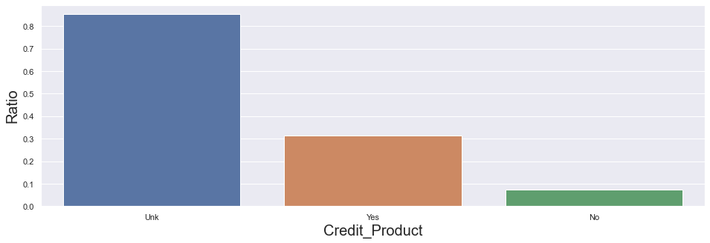
- People already having some kind of credit product are way more likely to respond positively to offer as compared to non-credit users.

11. Avg Account Balance
Average Account Balance for the Customer in last 12 Months
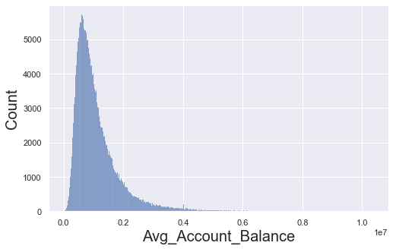
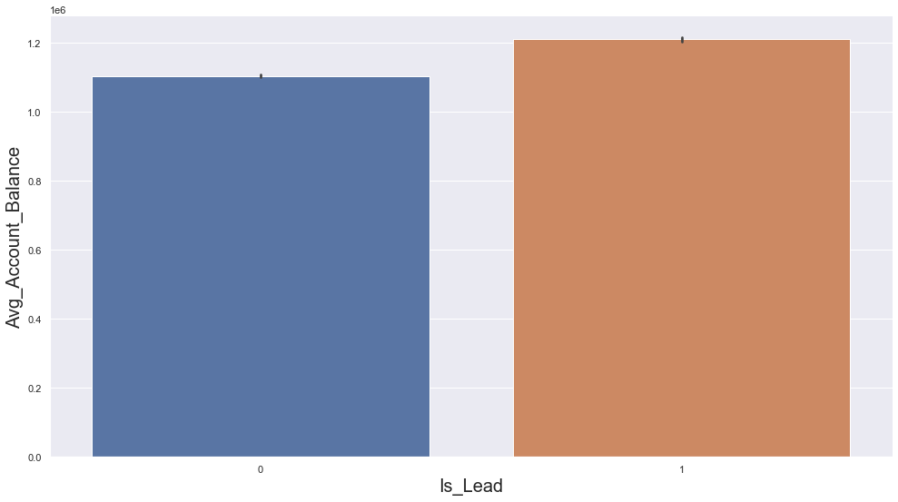
- Positively responding customers have a slightly higher average account balance on an average as compared to negatively responding customers.

12. Is Active
If the Customer is Active in last 3 Months
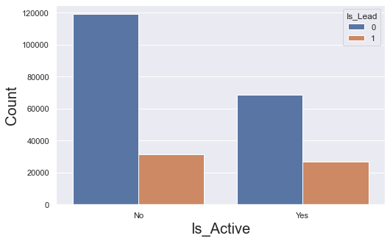
Response Rate from Is_Active
we create a new variable here names v which calculates the response ratio whether the customer is active or not using group by function. We check for value 1 in the 0 and 1 for whether customer is active or not
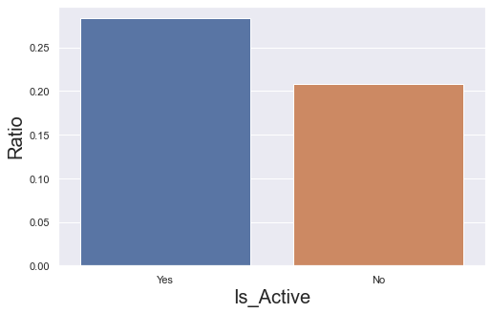
- Active Customers(in last 3 months) are slightly more likely to respond positively as compared to inactive customers.

create a list of columns that are not features and printing the list
divide the numeric and categorical features into two arrays.
Numeric features: ['Age', 'Vintage', 'Avg_Account_Balance', 'Credit_Product_Known']
Categorical features: ['Gender', 'Region_Code', 'Occupation', 'Channel_Code', 'Credit_Product', 'Is_Active']

13. Numerical Feature Interactions
Here we will check the interactions of the numeric features with our target variable Is_Lead
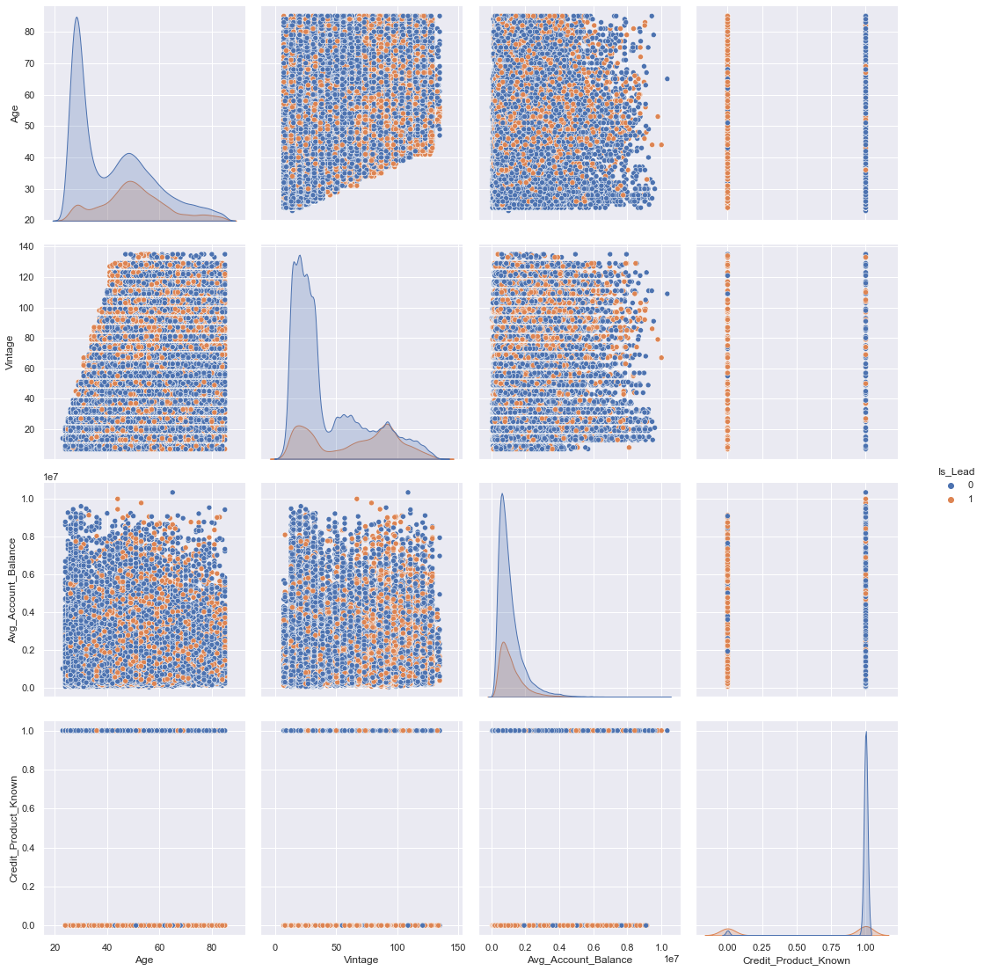checking for correlations between the numeric features
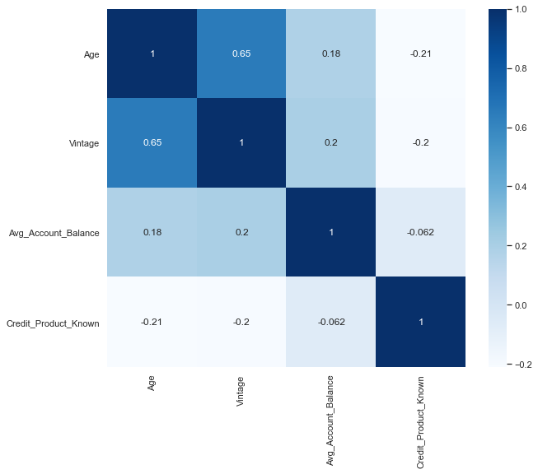

KFolds Split
Before we move on to feature engineering, it is always a good idea to perform cross validation splits. In that way, we will not risk any data leakage and would be more certain of the validation set being aptly representative of the real world unknown data.
Kfolds = 5

Feature Encoding
First let's convert all the categorical features to numbers. I have decided to use Label encoder after lot of experiments with other types of categorical encoders and decision is made based on CV ROC score.
features: ['Gender', 'Age', 'Region_Code', 'Occupation', 'Channel_Code', 'Vintage', 'Credit_Product', 'Avg_Account_Balance', 'Is_Active', 'Credit_Product_Known']

Numeric features: ['Age', 'Vintage', 'Credit_Product', 'Avg_Account_Balance', 'Is_Active', 'Credit_Product_Known']
Categorical features: ['Gender', 'Region_Code', 'Occupation', 'Channel_Code']

High Cardinality columns: ['Region_Code']
Low Cardinality columns: ['Gender', 'Occupation', 'Channel_Code']

Clustering
We clustered the customers to some groups using the given features and use them as one of the features to identify what cluster the customer belongs to. We created 3 clusters and performed KMeans clustering.

Feature Selection
We need to select only the important features for better performance of the model. As unnecessary in best case scenario will not add to any productive calculation of the algorithm or in worst case scenario 'confuse' the model.
To do the same let's create a wrapper class that has all the built-in statistical tests required to perform feature selection and takes some basic inputs from user and spits out the required features.
Custom univariate feature selection wrapper on different univariate feature selection models from scikit-learn.
Through iterations it has been found that all features are important. Hence we are not doing any feature selection and thus the n_features parameter has value 1.0
11 Features Selected
['Gender', 'Age', 'Region_Code', 'Occupation', 'Channel_Code', 'Vintage', 'Credit_Product', 'Avg_Account_Balance', 'Is_Active', 'Credit_Product_Known', 'cluster']

Models Benchmarking
We created a benchmarking function which finds the best single model for this dataset. We considered the following models and calculated
Model : Evaluation score mean(std)
Gauss(GaussianNB) : 0.693042 (0.002)
QDA(QuadraticDiscriminantAnalysis) : 0.852897 (0.002)
lr(LogisticRegression) : 0.447428 (0.002)
rf(RandomForestClassifier) : 0.855313 (0.002)
lgbm(LGBMClassifier) : 0.873972 (0.002)
BalBag(BalancedBaggingClassifier) : 0.840931 (0.002)
BalRF(BalancedRandomForestClassifier) : 0.862691 (0.002)
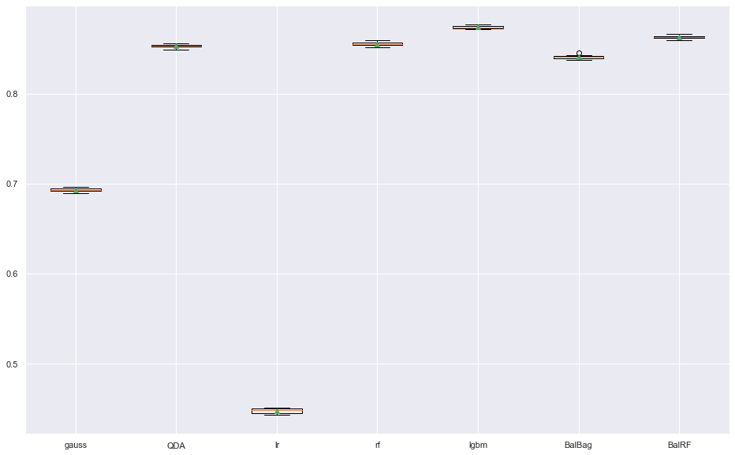

Best Model
Prediction using the best single model.
Best Score: 0.874
Best Model: lgbm
ID Is_Lead
0 VBENBARO 0.039830
1 CCMEWNKY 0.864890
2 VK3KGA9M 0.057406
3 TT8RPZVC 0.022580
4 SHQZEYTZ 0.022790

Final Solution
Created a custom ensemble using the best single model from above and training on folds while tracking the OOF scores.
100%|████████████████████████████████████████████████████████████████████████████████████| 5/5 [03:04<00:00, 36.89s/it]
ROC: 0.8748091709935398

ID Is_Lead
0 VBENBARO 0.040338
1 CCMEWNKY 0.863693
2 VK3KGA9M 0.061764
3 TT8RPZVC 0.022568
4 SHQZEYTZ 0.023227

Summary

We made multiple notebook with multiple models. We did the EDA in each followed by the modelling part. In this Submission i combined the top 7 models and showed why I rejected the other 6 and choosing only 1 model. In this document you can see how I came to that conclusion. We have used LGBM classifier model in this.

